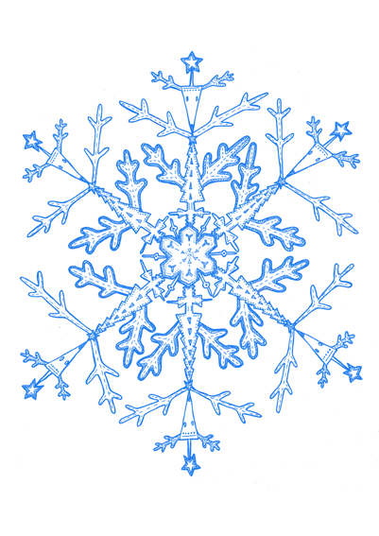
Merry “Cook”mas
Your goal is to come up with a recipe that resembles a main meal,
side dish or baked item (cookies, etc.).

Directions
- Create a recipe consisting of approximately fifteen different ingredients. (They MUST be real and edible!)
- Your recipe must include between ten and twenty steps. (Your recipe must be written on the given sheet)
- Each ingredient must be in fraction form. ($\frac{1}{2}$ flour, $\frac{1}{4}$ lb. of chicken)
- You may NOT repeat fractions. You must have fifteen different fractions.
- You must convert your fractions to decimals and percents on the conversion chart.
- Your recipe must be easy to understand. (A stranger must be able to pick it up and prepare it without your assistance)
- When you are finished with all of the above and the recipe has been prepared, take a picture of it and attached it to the designated sheet.
- Final step: re-write recipe on attached sheet as if it were doubled, tripled, reduced by half, etc. (only one)

Ingredients

- _____________________________ 2. ____________________________
- _____________________________ 4. ____________________________
5. _____________________________ 6. ____________________________
7. _____________________________ 8. ____________________________
9. ______________________________ 10. ____________________________
11. ______________________________ 12. ____________________________
13. ______________________________ 14. ____________________________
15. ______________________________
Name:____________________

Merry “Cook”mas!
Name of dish:______________________
(and attached photo)

